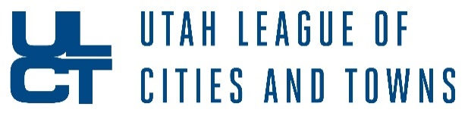

Today the Governor announced an enhanced effort to connect Utah businesses with federal resources. That effort is being spearheaded by a new Rapid Response Team composed of volunteers from The Utah Economic Response Task Force, World Trade Center Utah, and the SBA Utah District Office. That organization will be supporting the SBA as they respond to inquiries about and applications to new federal assistance in the CARES Act.

**Local governments are being called upon to communicate information about these programs with businesses in their communities.**

1. **Paycheck Protection Program**

The Paycheck Protection Program (PPP) is a cornerstone of aid offered to provide small business loans on favorable terms to borrowers impacted by the current state of economic uncertainty. The demand for funding in this program will outstrip the supply, so it is imperative that businesses reach out to their banks **this week** to qualify for loans. Utah banks and credit unions are working around the clock to provide aid to small businesses.

* More information can be found here: <https://coronavirus.utah.gov/business/#federal-resources>
* The Utah Economic Response Task Force put together this FAQ: <https://business.utah.gov/wp-content/uploads/2020/04/Utah-Economic-Response-Task-Force_Email2-1.pdf>

1. **Economic Injury Disaster Loan Program**

The Small Business Administration’s Economic Injury Disaster Loan Program (EIDL) provides small businesses with working capital loans of up to $2 million to provide vital economic support to small businesses to overcome the temporary loss of revenue they are experiencing. All small business owners in Utah are eligible to apply for a low-interest loan.

* More information can be found here: <https://www.sba.gov/disaster-assistance/coronavirus-covid-19#section-header-3>

1. **Utah Leads Together Small Business Bridge Loan**

The Utah Leads Together Small Business Bridge Loan provides short-term loans ($5,000 - $20,000) to businesses with 50 or fewer employees to bridge the gap until federal funding is disbursed. Applications for the first cycle of the Bridge Loan Fund are currently being evaluated. The next cycle for applications begins on April 13, 2020.

* More information can be found here: <https://coronavirus.utah.gov/business/>

If businesses in your community have any questions about these different assistance programs, they’re encouraged to contact the Rapid Response Team by either submitting questions to this [URL](https://wtcutah.formstack.com/forms/rapid_response_team_intake) (<https://wtcutah.formstack.com/forms/rapid_response_team_intake>) or contacting the SBA disaster assistance customer service center by phone (1-800-659-2955) or by email ([disastercustomerservice@sba.gov](mailto:disastercustomerservice@sba.gov)).